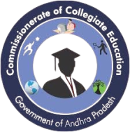
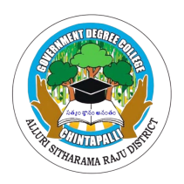
GOVERNMENT DEGREE COLLEGE, CHINTAPALLI
Alluri sita ramaraju district.
Affiliated to Andhra university

REPORT
ON

EXTRA CURRICULAR
&
CO-CURRICULAR ACTIVITIES

REPORT ON EXTRA-CURRICULAR & CO-CURRICULAR ACTIVITIES
Government Degree College, Chintapalli
Alluri Sitarama Raju District
Academic Year: 2025–2026

Introduction
Education is not limited to classroom teaching; it extends beyond academics through various co-curricular and extra-curricular activities. These activities play a vital role in the holistic development of students by enhancing their physical, mental, social, and emotional well-being.
Government Degree College, Chintapalli actively organizes a wide range of activities to promote student participation, leadership, creativity, and social responsibility.
Objectives
The main objectives of conducting co-curricular and extra-curricular activities are:
- To promote all-round development of students
- To enhance communication and leadership skills
- To encourage teamwork and cooperation
- To develop creativity and talent
- To promote physical fitness and mental well-being
- To create social awareness and responsibility
Co-Curricular Activities Conducted
Co-curricular activities are directly related to academic learning and support classroom education.

📚 Academic Activities
- Seminars & Workshops: Conducted by various departments on subject-related topics
Introduction
Government Degree College, Chintapalli has taken active initiatives to enhance students’ academic knowledge and awareness by organizing seminars on important contemporary topics. These seminars provided a platform for students to gain insights into emerging issues and develop critical thinking skills.
2. Details of Seminars Conducted
The college successfully organized three seminars on the following topics:
Seminar on Intellectual Property Rights (IPR)
- The seminar focused on creating awareness about Intellectual Property Rights, including patents, copyrights, and trademarks.
- Students were educated on the importance of protecting innovations and creative works.
- The session helped students understand legal rights and responsibilities related to intellectual property.
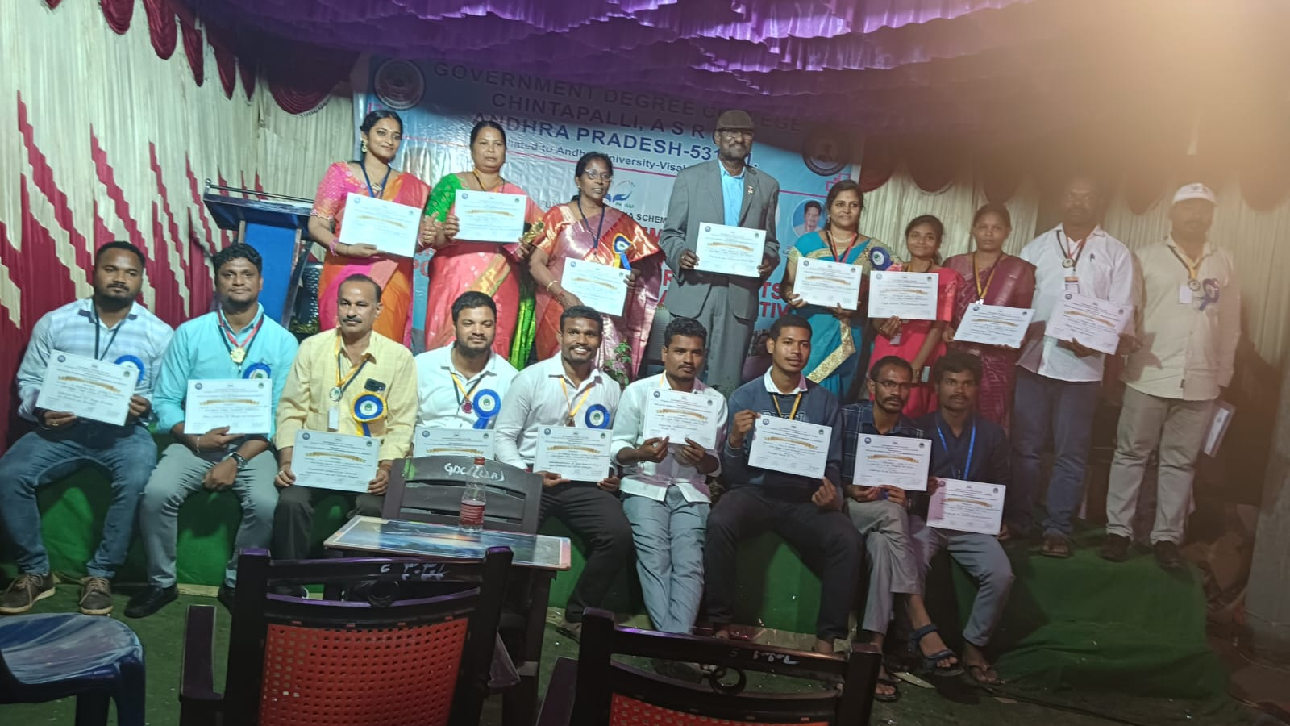

Seminar on Digital Literacy
- This seminar emphasized the importance of digital literacy in today’s technology-driven world.
- Topics covered included:
  - Basic computer skills
  - Internet usage
  - Cyber safety and security
- Students gained awareness about responsible and effective use of digital tools.
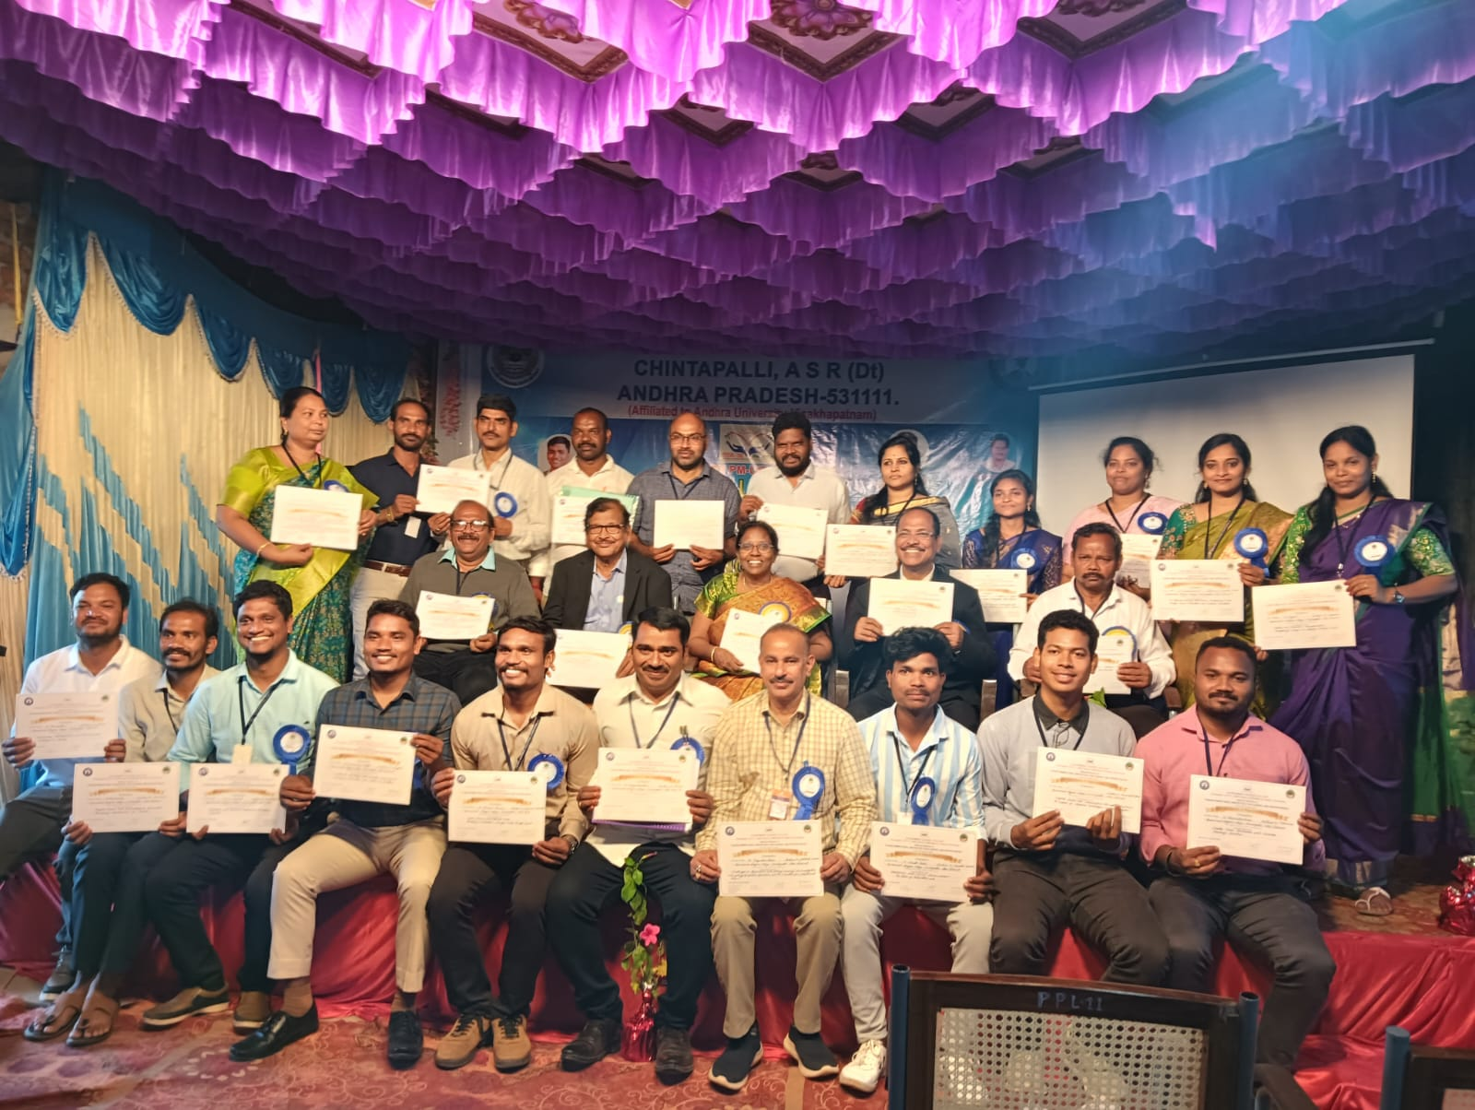

Seminar on Transforming India
- The seminar highlighted the concept of Transforming India with focus on development initiatives and nation-building.
- Key areas discussed:
  - Digital India
  - Skill India
  - Economic and social development
- Students were encouraged to contribute towards the progress of the nation.
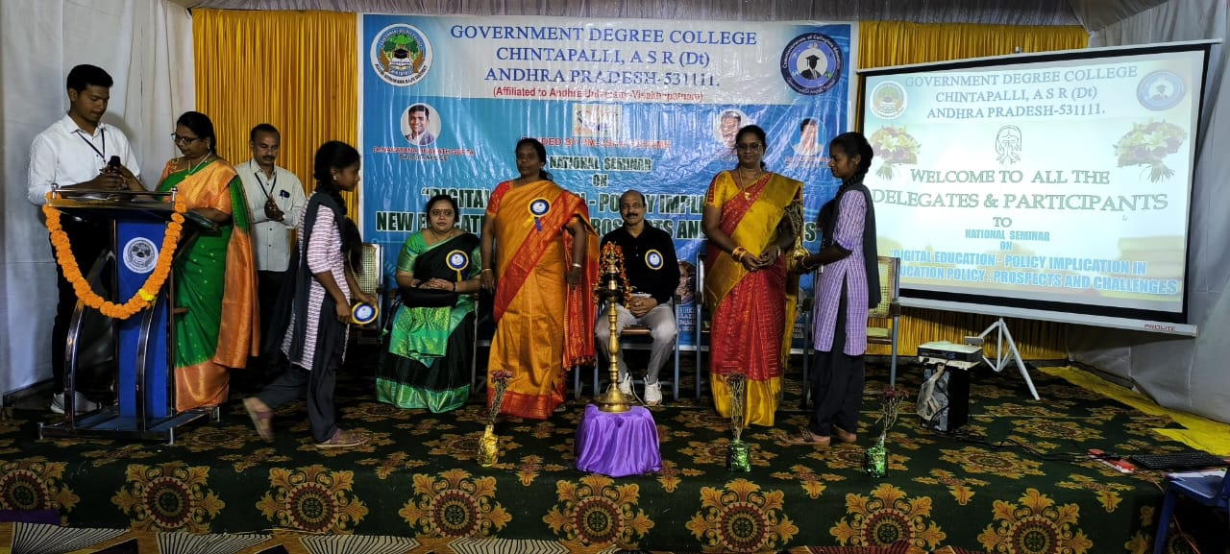

Objectives of the Seminars
- To enhance students’ awareness on current issues
- To improve knowledge beyond the curriculum
- To develop analytical and thinking skills
Participation
Students from BA, BCom, and BSc actively participated in all three seminars. Faculty
Outcomes
- Improved awareness on intellectual property and digital skills
- Better understanding of national development initiatives
- Enhanced confidence and communication skills
- Increased student engagement in academic activities

Guest Lectures
A Guest Lecture on “Awareness on Drugs and Substance Abuse” was organized at Government Degree College, Chintapalli with the objective of educating students about the harmful effects of drug addiction and promoting a healthy lifestyle. The program aimed to create awareness among youth about the dangers of substance abuse and the importance of making responsible life choices.
The program was conducted under the guidance and instructions of Principal Dr. M. Vijaya Bharathi, ensuring active participation and successful organization.
Objectives
- To create awareness about drug abuse and its harmful effects
- To educate students about different types of drugs and addiction
- To promote healthy and responsible behavior among youth
- To prevent drug usage among students
- To encourage students to lead a disciplined and drug-free life
Guest Speaker
The guest lecture was delivered by Sri P.ARUN KUMAR,SUBNSPECTOR OF POLICE who shared valuable insights on the causes, consequences, and prevention of drug abuse .
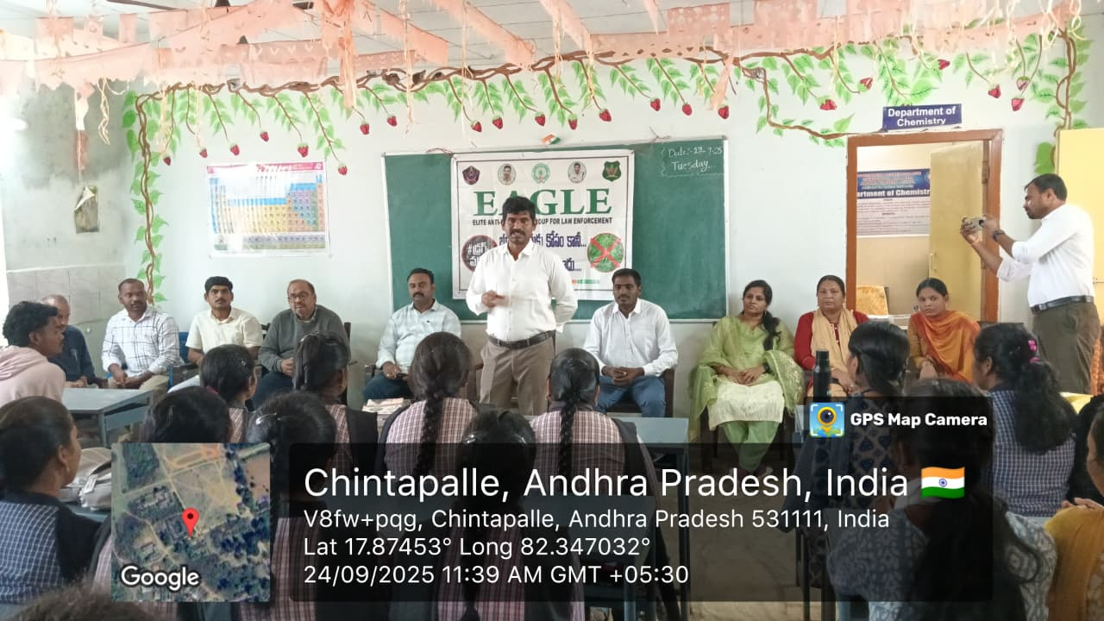

Group Discussions & Debates:
Encouraged critical thinking and communication skills.
A Debate Competition on the topic “Parliament Sessions and Their Importance in Democracy” was organized at Government Degree College, Chintapalli to enhance students’ awareness about the functioning of the Indian parliamentary system. The program aimed to develop critical thinking, communication skills, and understanding of democratic processes among students.
The event was conducted under the guidance and instructions of Principal Dr. M. Vijaya Bharathi, ensuring smooth and successful organization.
Objectives
- To create awareness about the functioning of Parliament
- To enhance debating and public speaking skills
- To encourage critical thinking on national issues
- To promote active participation in democratic discussions
About Parliament Sessions
The Parliament of India conducts three main sessions:
- Budget Session
- Monsoon Session

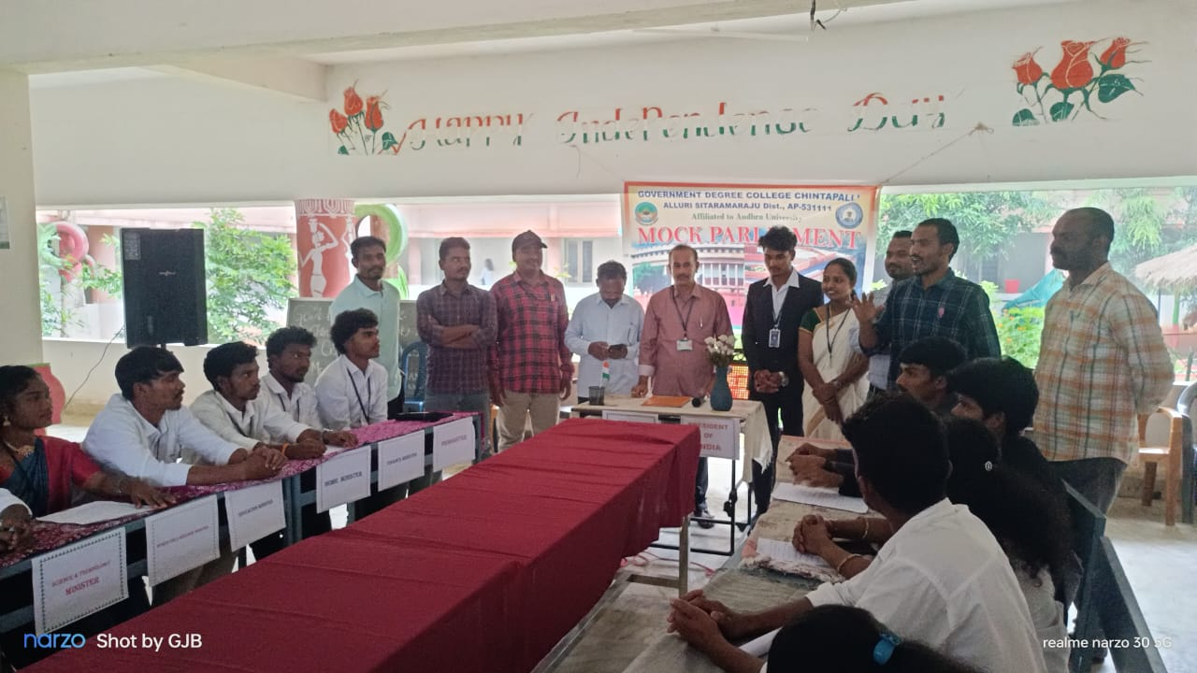

Quiz Competitions:
Subject-based quizzes to improve knowledge
A Quiz Program on Financial Literacy was conducted at Government Degree College, Chintapalli to enhance students’ knowledge about financial concepts, money management, and economic awareness. The program aimed to equip students with essential financial skills required for personal and professional life.
The event was organized under the guidance and instructions of Principal Dr. M. Vijaya Bharathi, ensuring active participation and smooth execution.
Objectives
- To promote financial awareness among students
- To develop knowledge about banking, savings, and investments
- To encourage responsible financial behavior
- To enhance analytical and quick-thinking skills through quiz competition
Topics Covered
- Basics of banking and financial institutions
- Savings and investment options
- Digital payments and financial security
- Budgeting and personal finance management
- Government financial schemes and initiatives
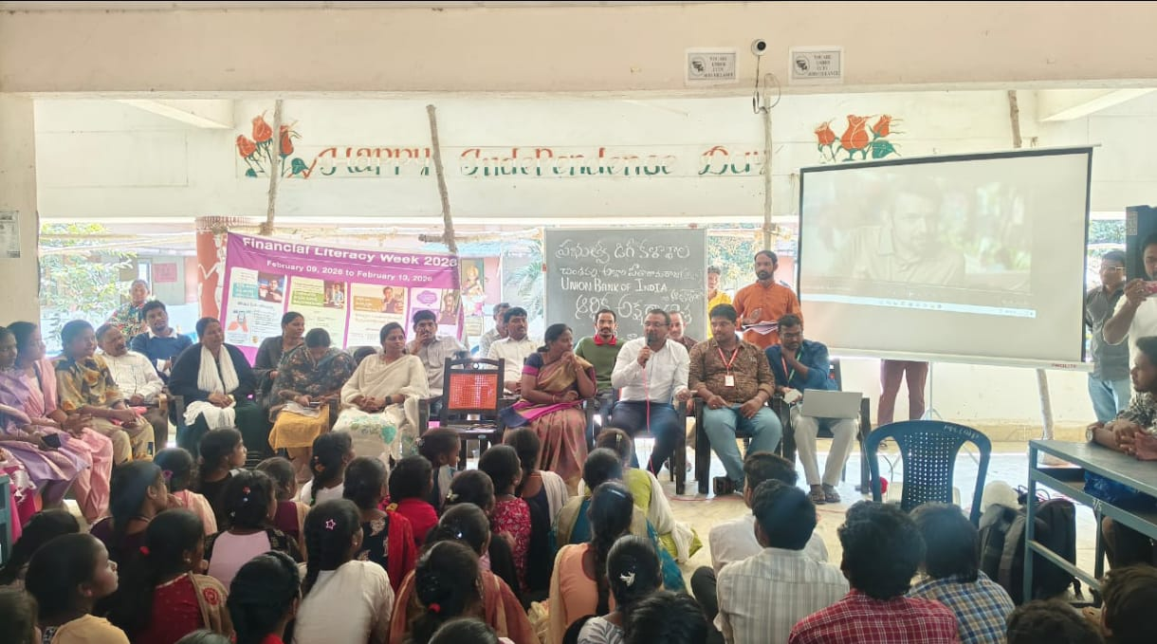

Extra-Curricular Activities Conducted
Extra-curricular activities focus on overall personality development beyond academics.
Sports & Games
Students of Government Degree College, Chintapalli actively participated in prestigious sports events such as Inter-University Volleyball Competitions and the national-level initiative Khelo India. These platforms provide opportunities for students to showcase their talent, improve physical fitness, and gain competitive experience.
The participation was encouraged and supported under the guidance of Principal Dr. M. Vijaya Bharathi, promoting sports as an essential part of student development.

Participation Details
- Event 1: Inter-University Volleyball Competition
- Event 2: Khelo India Sports Events
- Participants: Students from various courses (B.A., B.Sc., B.Com)
- Level: University and National Level

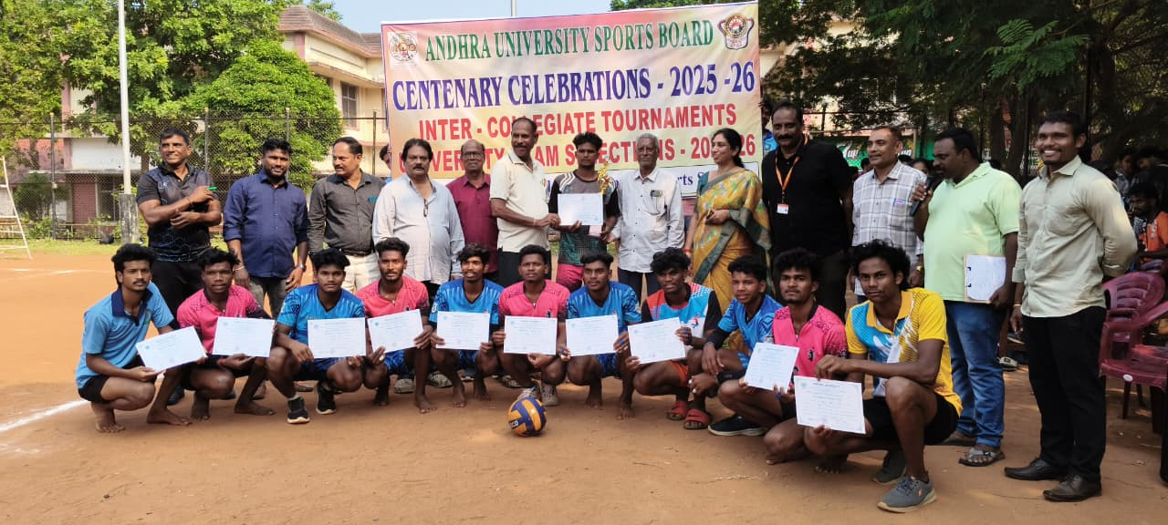

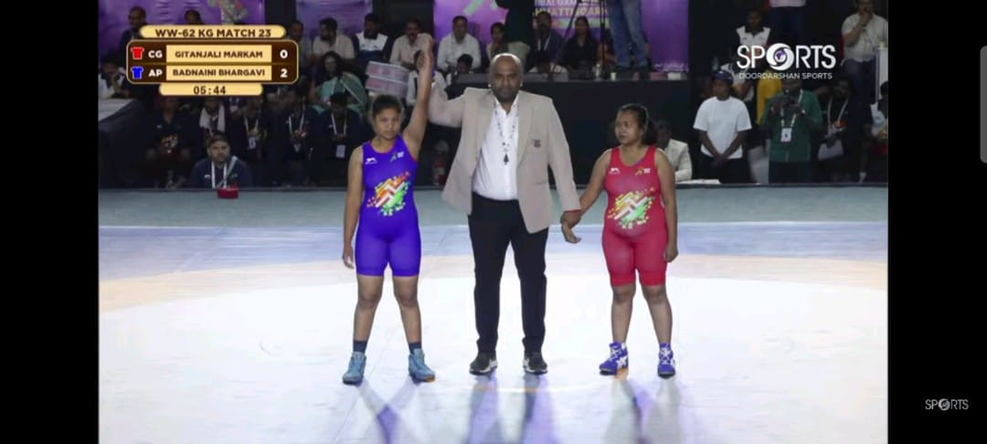
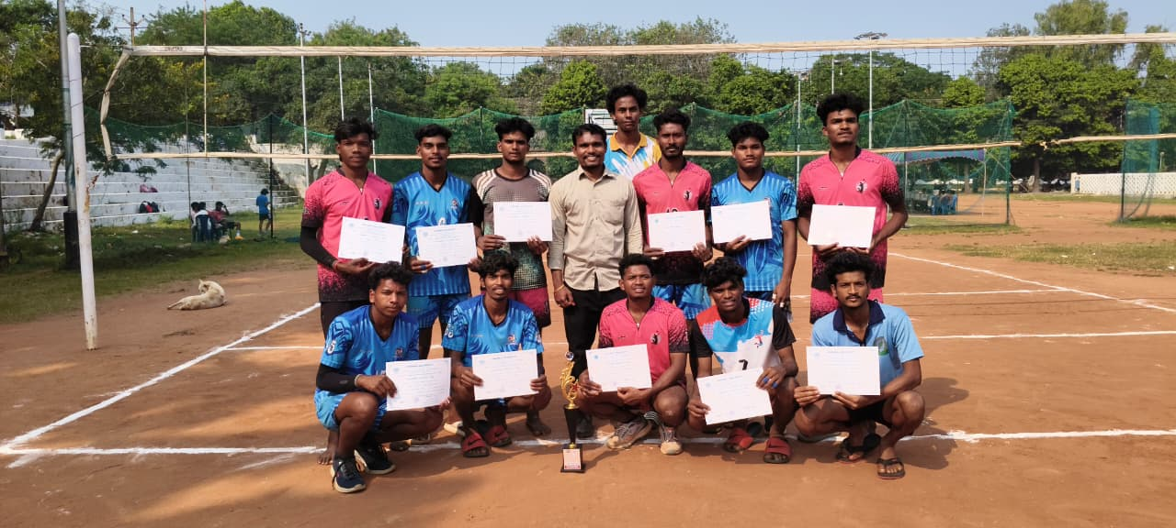
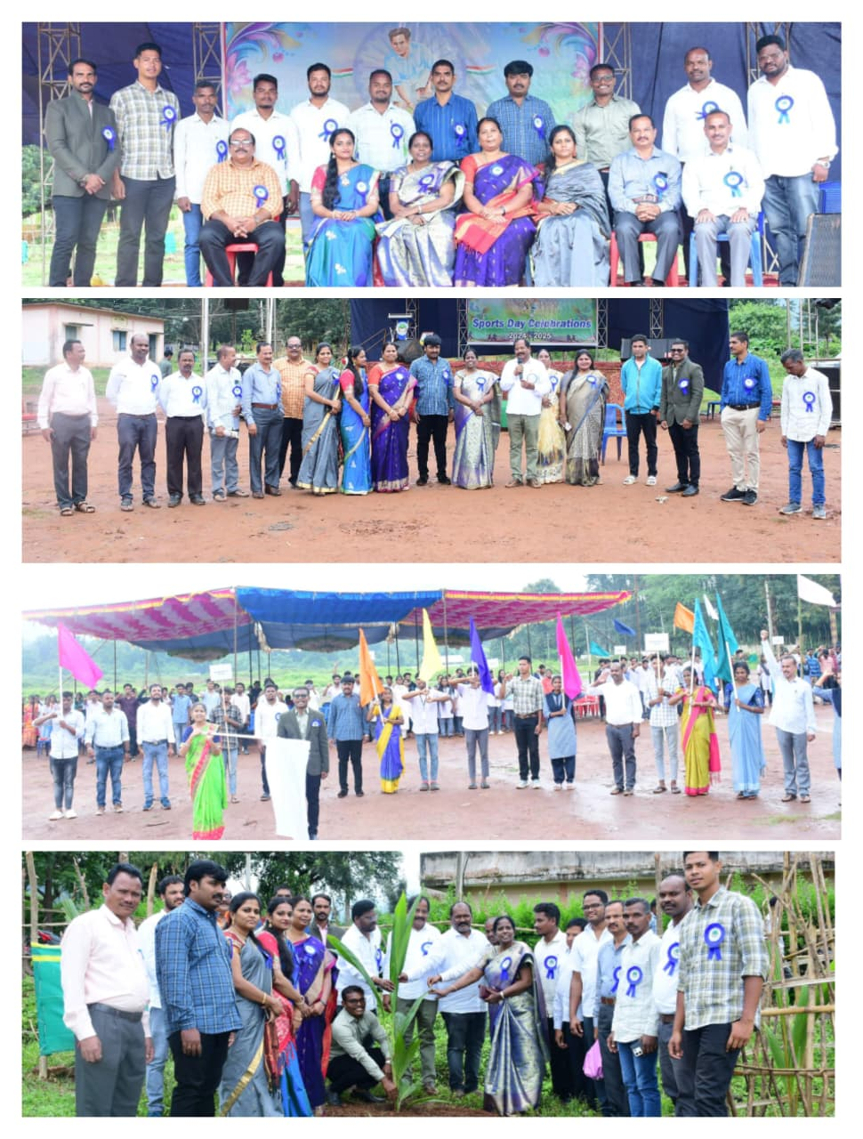

Cultural Activities
Dance, music, and drama performances
Cultural Activities in Dance and Singing were conducted at Government Degree College, Chintapalli to promote artistic talents and encourage student participation in extracurricular activities. The event provided a platform for students to showcase their creativity, confidence, and cultural expression.
The program was organized under the guidance and instructions of Principal Dr. M. Vijaya Bharathi, ensuring the successful conduct of the event.
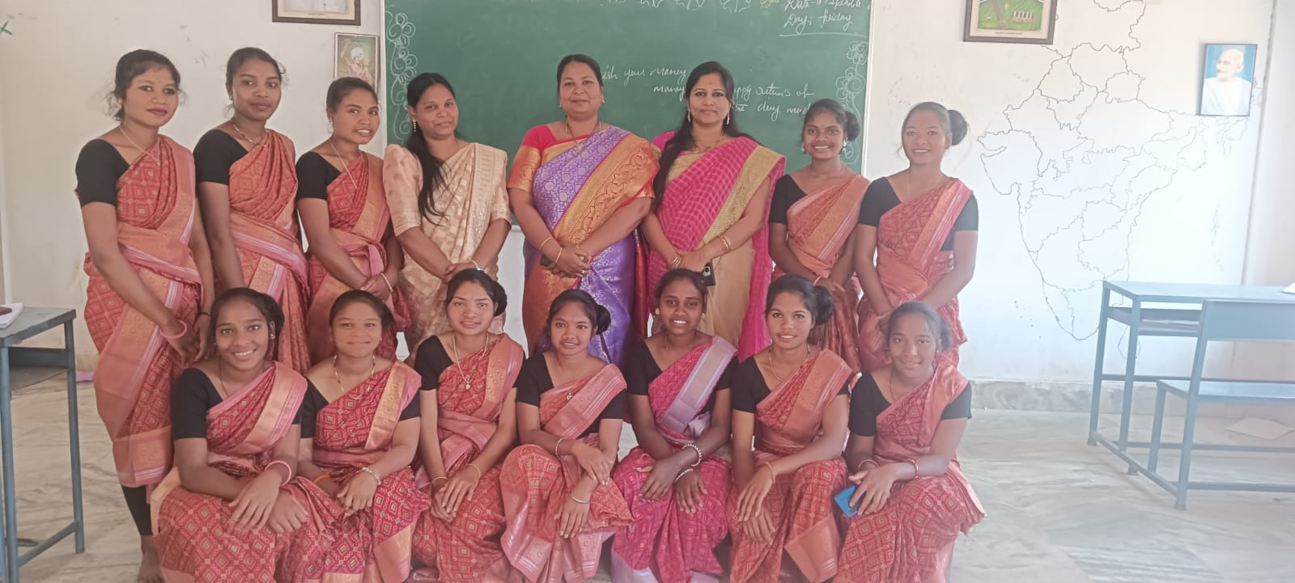

Participation in youth festivals
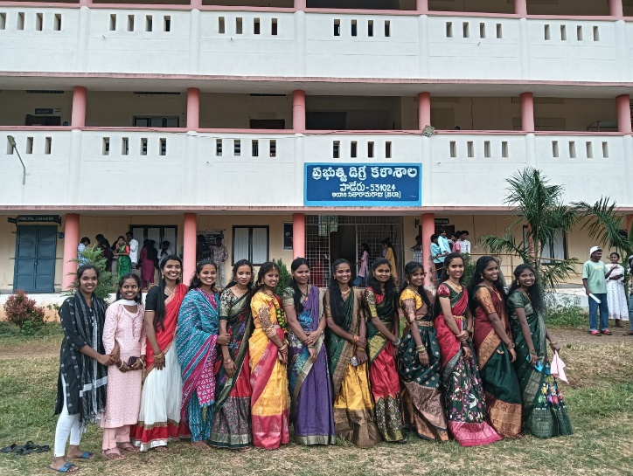
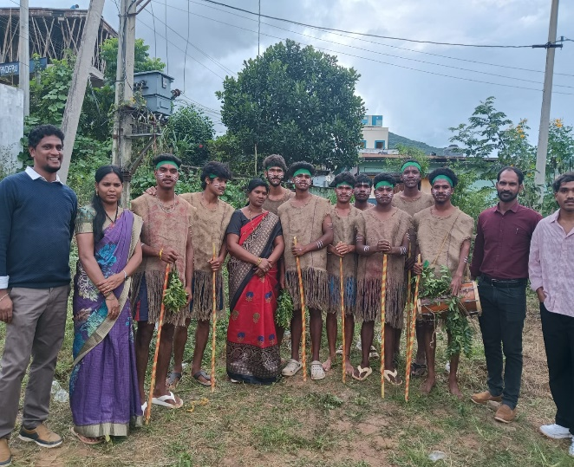
Students of Government Degree College, Chintapalli actively participated in the Youth Festival held at Paderu on the occasion of National Youth Day. The festival was organized to celebrate the spirit of youth, talent, and creativity, and to encourage active participation in cultural and social activities.

Celebrations of important days

Independence Day
The Independence Day was celebrated with great enthusiasm and patriotic spirit at Government Degree College, Chintapalli. The celebration aimed to honor the sacrifices of freedom fighters and to in still a sense of national pride and unity among students.
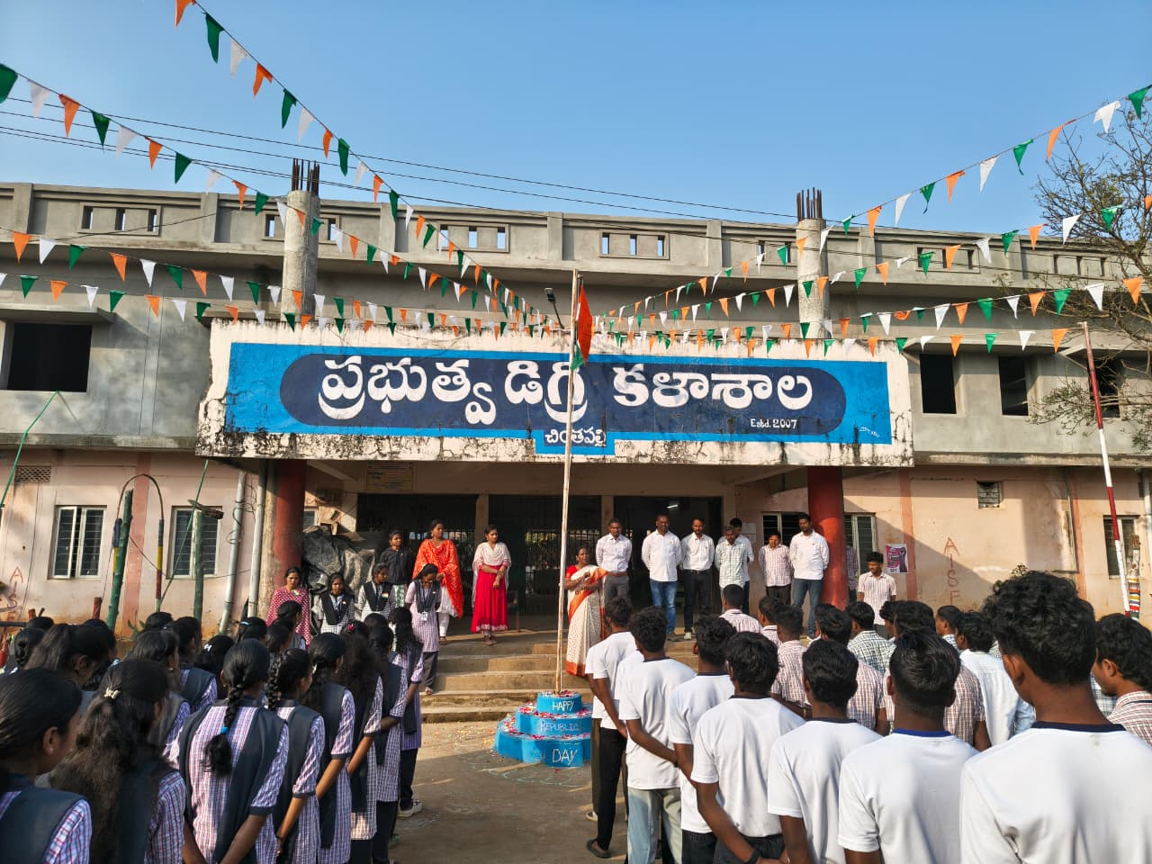
Republic Day
The Republic Day was celebrated with great pride and patriotic fervor at Government Degree College, Chintapalli. The day marks the adoption of the Constitution of India and reflects the democratic values of the nation. This independence programme conduct ar Mangalapalem village with the local tribal people to get awareness.

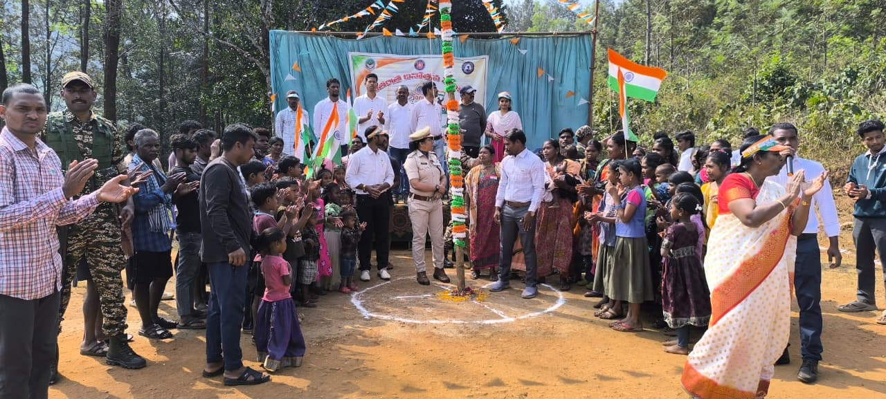

NSS & Social Activities
A Clean and Green Campaign was organized at Government Degree College, Chintapalli as part of the Swachh Bharat Abhiyan. The campaign aimed to promote cleanliness, environmental awareness, and sustainable practices among students and the local community.
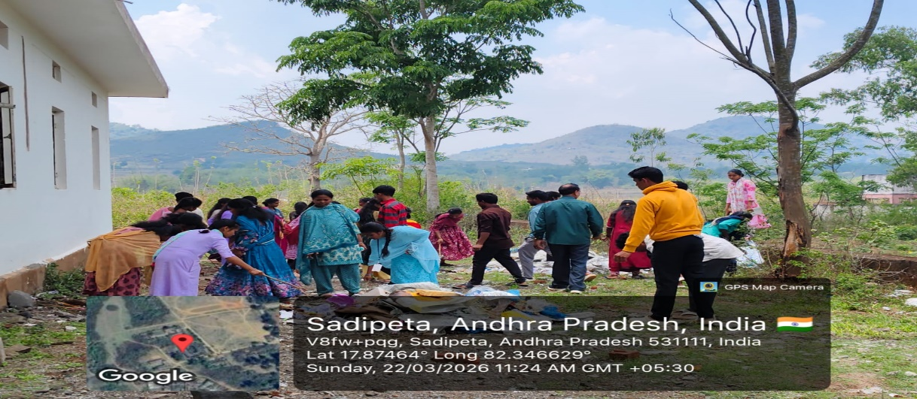
- Rural development and community service activities
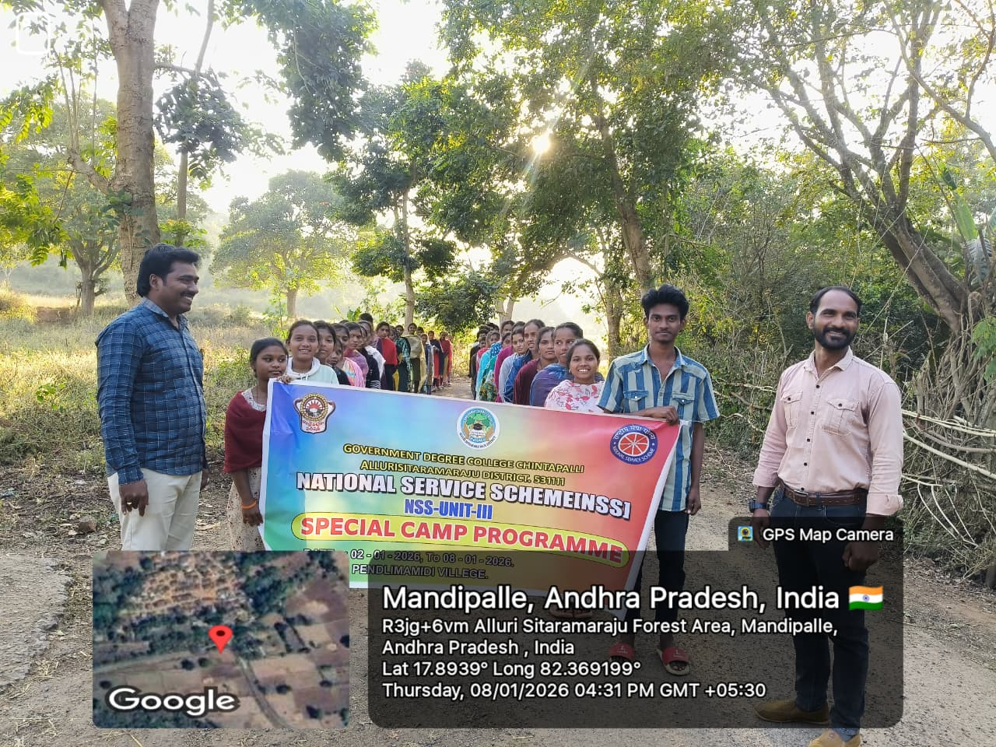

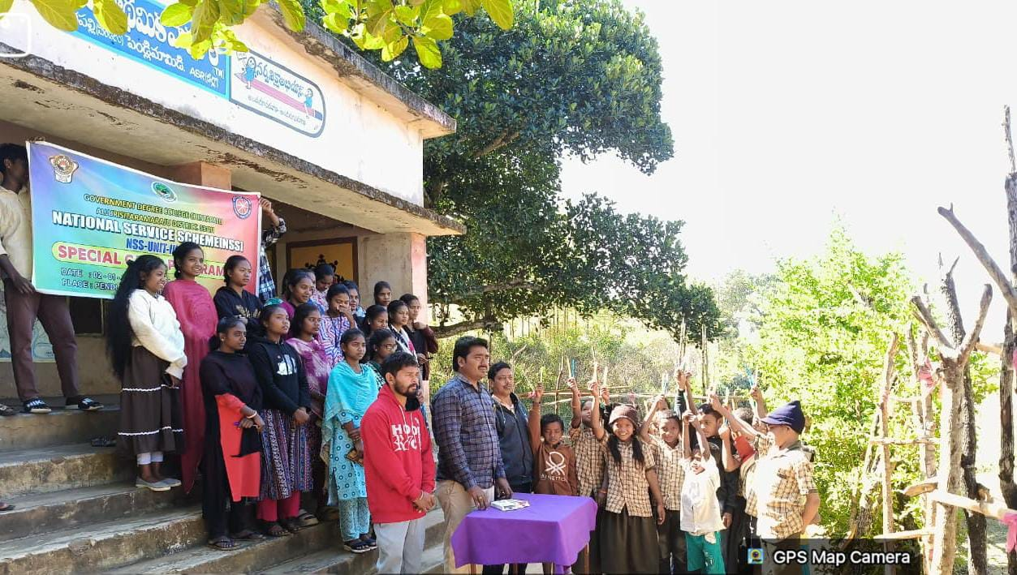

College Events
- Freshers Day celebrations
freshers Day is an important event organized to warmly welcome the newly admitted students into the college community. It helps in creating a friendly atmosphere, building confidence among students, and encouraging interaction between seniors and juniors.
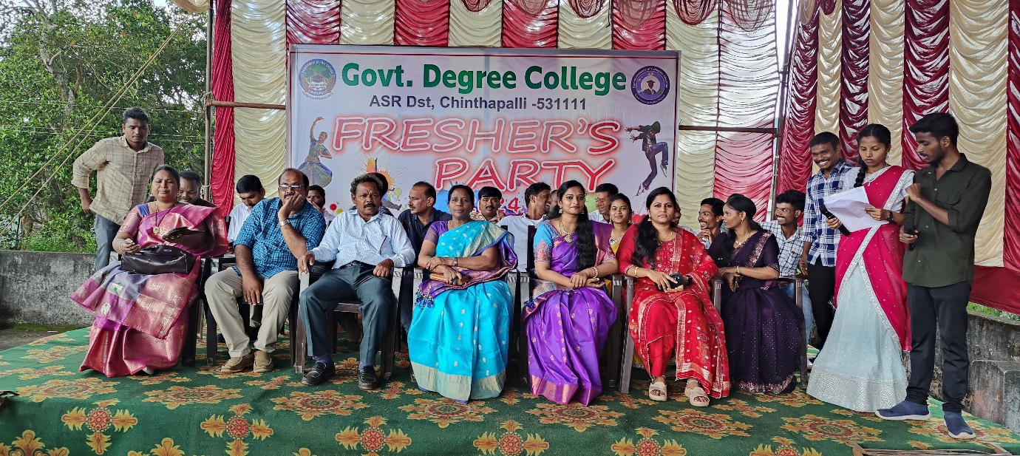
Government Degree College, Chintapalli organized Freshers Day with great enthusiasm to make the new students feel comfortable and motivated.
Farewell functions
A Farewell Function was organized at Government Degree College, Chintapalli to bid a warm and memorable farewell to the outgoing final-year students of B.A., B.Sc., and B.Com. The event was filled with emotions, gratitude, and celebration, marking the end of an important phase in the students’ lives.
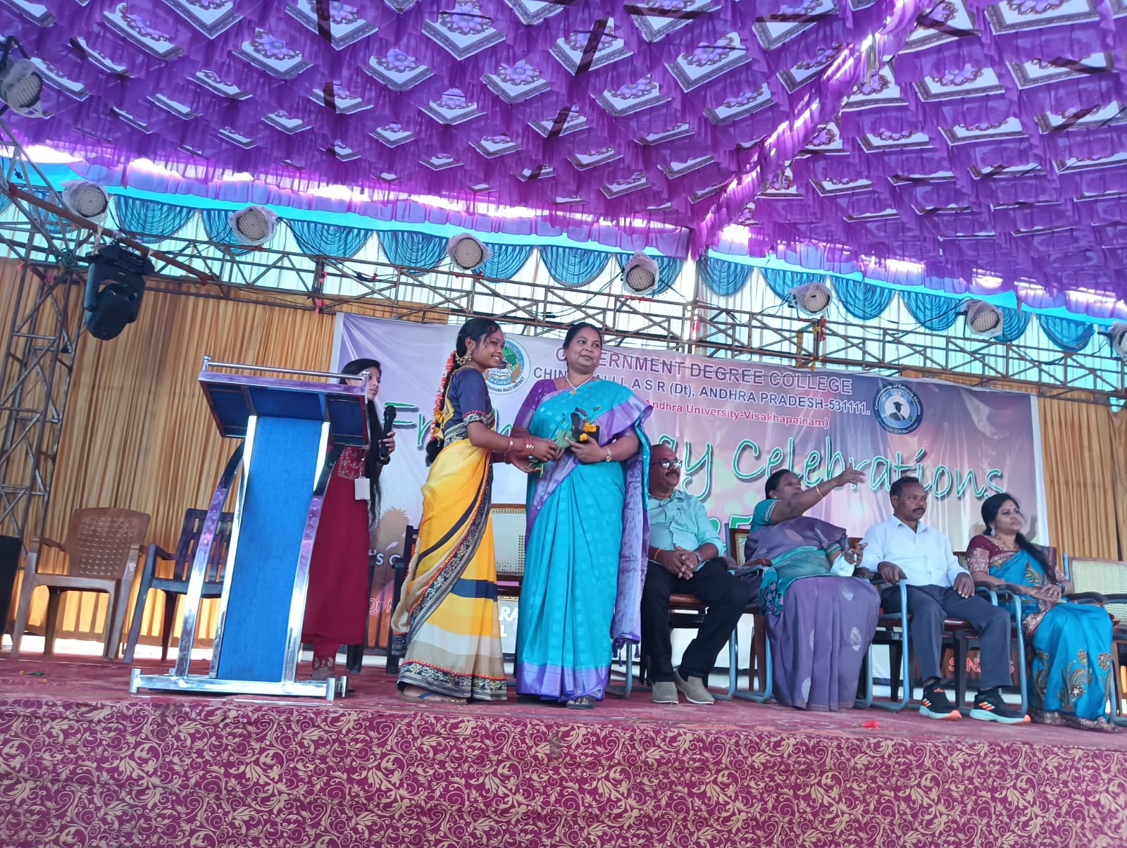
Special Programmes Conducted
- Field trips to educational and tourist places

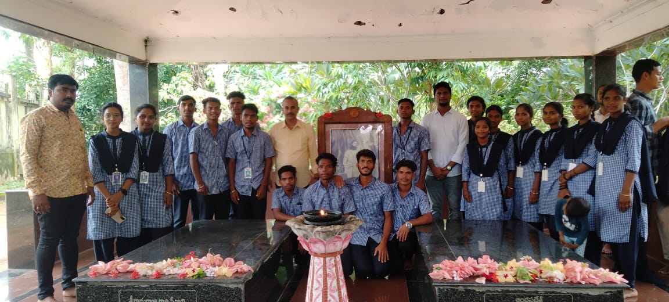

Certificate courses (skill-based programs)
Government Degree College, Chintapalli organized a Certificate Course on Bamboo Crafting to promote skill development and self-employment among students. Bamboo crafting is an eco-friendly and sustainable traditional art that provides livelihood opportunities, especially in tribal regions.
The program was conducted under the guidance and instructions of principal dr. m. vijaya bharathi and successfully implemented with the support of the trainer sri dharmareddy prasad from maheswari educational society, achutapuram.
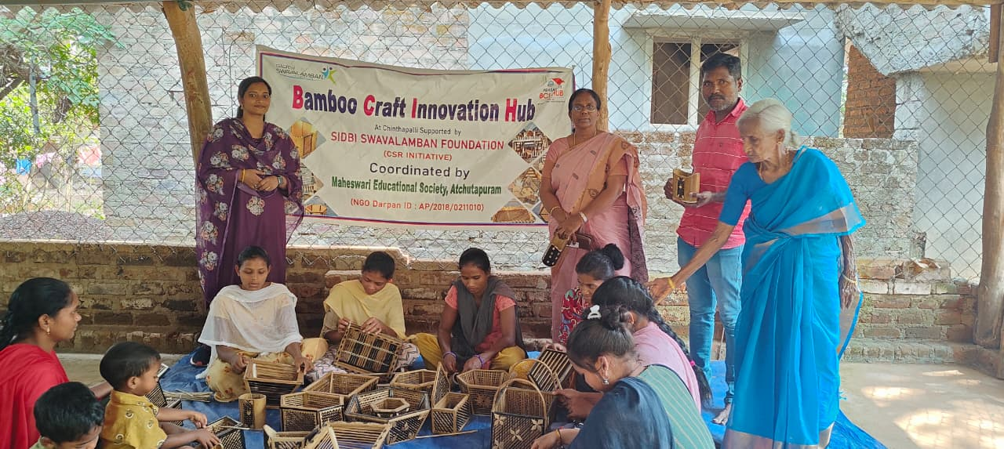

Awareness campaigns on social issues
An Awareness Campaign on the Disha Shakti App was conducted at Government Degree College, Chintapalli to educate students, especially women, about safety measures and the use of digital tools for protection. The app is an initiative by the Government of Andhra Pradesh to enhance women’s safety by providing quick access to emergency services
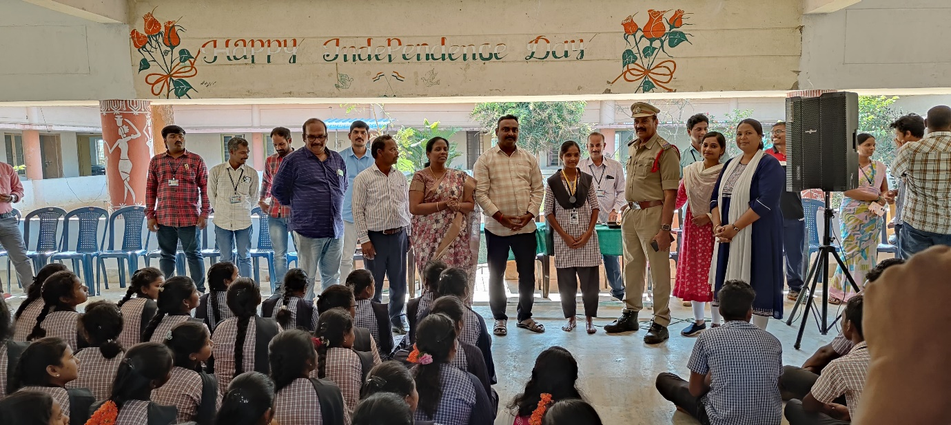
Career guidance and counseling sessions
A Career Guidance and Empowerment Program was organized at Government Degree College, Chintapalli to help students make informed career choices and develop essential skills for personal and professional growth. The program focused on guiding students towards higher education, employment opportunities, and self-development.
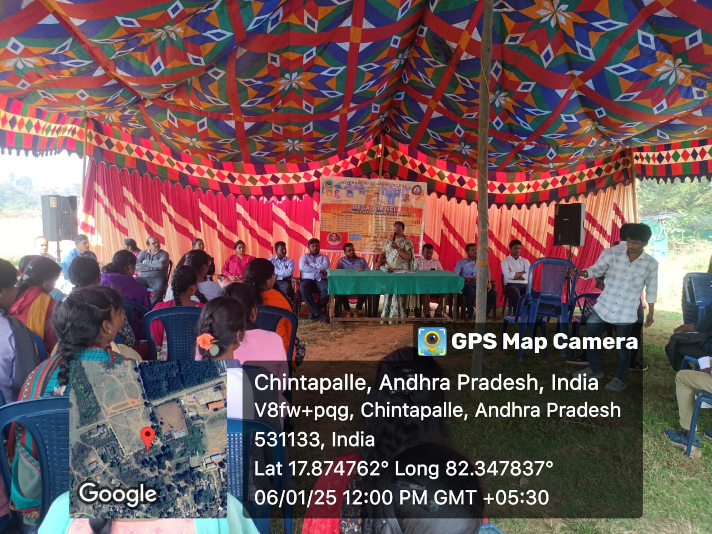

Student Participation
Students from BA, BCom, and BSc streams actively participated in all activities. These activities helped them build confidence, leadership qualities, and teamwork skills.
Outcomes
The activities conducted resulted in:
- Improved communication and leadership skills
- Increased student confidence and participation
- Better physical and mental health
- Enhanced social awareness and responsibility
- Development of creativity and talents
Conclusion
The Extra-Curricular and Co-Curricular activities conducted at Government Degree College, Chintapalli have significantly contributed to the overall development of students. These activities complement academic learning and prepare students for future challenges.
The college continues to encourage active student participation to ensure holistic education and personality development.

